**Department of Electronic and Telecommunication Engineering**

**University of Moratuwa**

**EN 2532 – Robot Design and Competition**

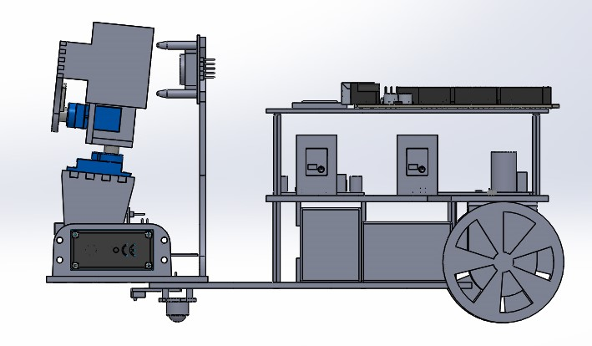**CAD Designs**

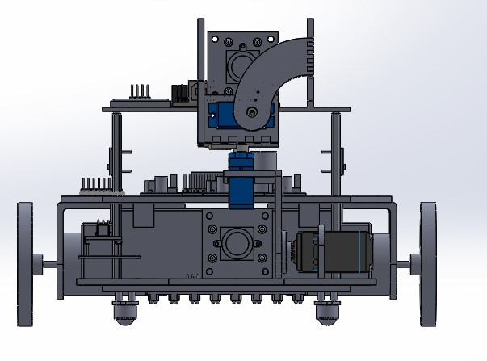

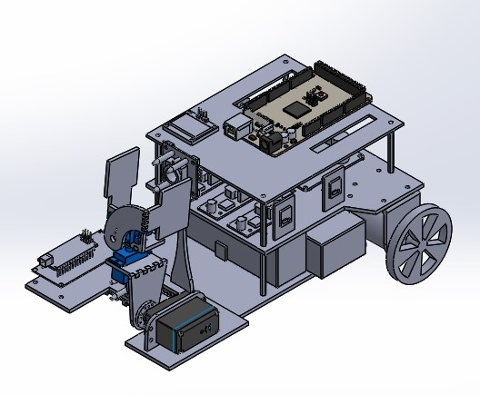

**Group** **BASC**

**Batman’s Attempt to Save Catwoman**

180195A Y.S. Ginige

180359G V.Y.N. Lokugama

180544U W.A.V. Ravihansa

180616T P.M.P.H. Somarathne

180641N A.Thieshanthan

180701B L.T.N. Wickremasinghe